BOOTCAMP .NET

garis horizontal

NAMA : KHOERUL MUTAQIN

ASAL : KOTA BREBES

TABEL : PERSON

[KHOERULMUTAQIN555@OUTLOOK.COM](mailto:KHOERULMUTAQIN555@OUTLOOK.COM)

19 Agustus 2022

WEEK TEST 1

SOAL MODULE PERSON

1. Buat query untuk menampilkan jumlah person di tiap region

QUERY :

select c.CountryRegionCode,c.name,count(pp.PersonType) as totaL_person

from Person.CountryRegion c

full outer join Person.StateProvince s on c.CountryRegionCode=s.CountryRegionCode

full outer join Sales.SalesTerritory st on s.TerritoryID= st.TerritoryID

full outer join Sales.Customer sc on st.TerritoryID= sc.TerritoryID

full outer join Person.Person pp on sc.CustomerID=pp.BusinessEntityID

group by c.CountryRegionCode,c.Name

OUTPUT

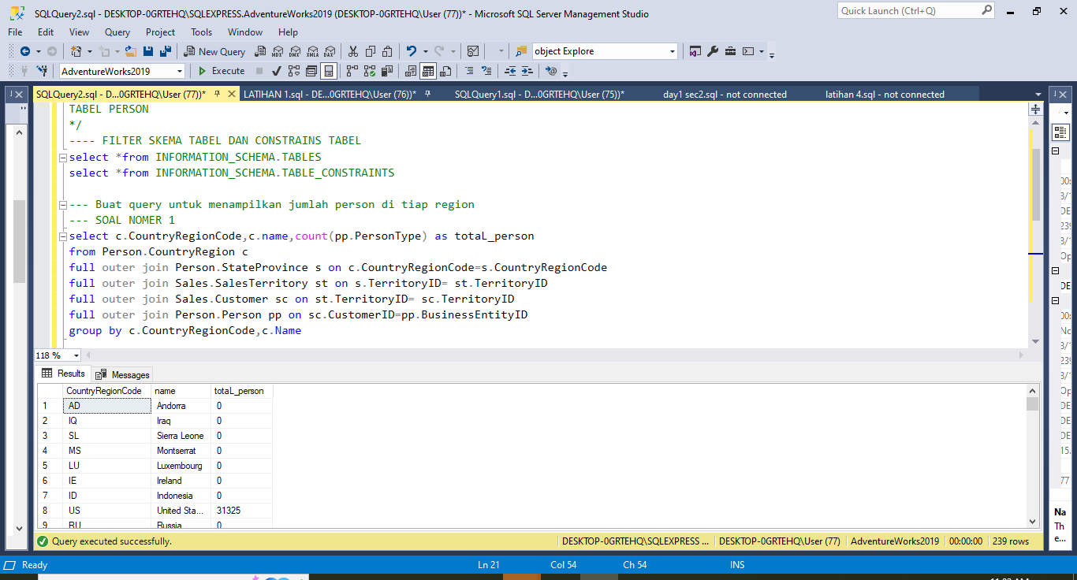

2. Tampilkan jumlah person berdasarkan person type nya

QUERY :

select PersonType,count(PersonType) as totaL_person

from Person.Person

group by PersonType

OUTPUT

